VIETNAM GENERAL CONFEDERATION OF LABOR

**TON DUC THANG UNIVERSITY**

**FACULTY OF INFORMATION TECHNOLOGY**



**FINAL PROJECT**

**INTRODUCTION TO COMPUTER VISION**

**FINGER COUNTING RECOGNITION TO ANSWER MULTIPLE CHOICE QUESTIONS**

*Instructing Lecturer*: **PHẠM VĂN HUY**

*Student’s name*: **NGUYỄN ANH KHOA- 519H0303**

**LÊ MINH – 519H0315**

**HO CHI MINH CITY, 2024**

VIETNAM GENERAL CONFEDERATION OF LABOR

**TON DUC THANG UNIVERSITY**

**FACULTY OF INFORMATION TECHNOLOGY**



**FINAL PROJECT**

**INTRODUCTION TO COMPUTER VISION**

**FINGER COUNTING RECOGNITION TO ANSWER MULTIPLE CHOICE QUESTIONS**

*Instructing Lecturer*: **PHẠM VĂN HUY**

*Student’s name*: **NGUYỄN ANH KHOA- 519H0303**

**LÊ MINH – 519H0315**

**HO CHI MINH CITY, 2024**

**THESIS AND DISSERTATION ACKNOWLEDGEMENTS**

After a semester of studying at Ton Duc Thang University, we want to give our sincere thanks to our teachers and Faculty of Information Technology for bringing a desired condition for students able to complete their course by giving many topics that can be applied in real-life.

We want to express our gratitude for our lecturer – Pham Van Huy. He helped us a lot on this course, giving us information about Machine Learning so that we can improve our knowledge. Also, we want to give thanks to each other member in this group. All of us are busy because everyone has other classes, but we still reply to each other when we need to. Once again, we are truly grateful for everyone that helped us to do this project. With challenging work and effort, we have successfully completed this report. Maybe this report has some mistakes because this is our first report on this course, so we really want to take the comments of the teacher and lecturer for our improvement in future projects.

With sincere thanks.

**REPORT COMPLETED AT**

**TON DUC THANG UNIVERSITY**

I hereby declare that this is my own project and is under the guidance of lecturer Pham Van Huy. The research contents and results in this topic are honest and have not been published in any publication before. The data in the tables for analysis, comments and evaluation are collected by the author himself from different sources, clearly stated in the reference section.

In addition, the project also uses a number of comments, assessments as well as data of other authors, other agencies and organizations, with citations and source annotations.

If I find any fraud, I will take full responsibility for the content of my project. Ton Duc Thang University is not related to copyright and copyright violations caused by me (if any).

*Ho Chi Minh, October 13, 2024*

*Author*

*Nguyễn Anh Khoa*

*Lê Minh*

**EVALUATION OF INSTRUCTING LECTURER**

**Confirmation of the instructor**

_______________________________________________________________________________________________________________________________________________________________________________________________________________________________________________________________________________________________________________________________________________________________________________________________________________

Ho Chi Minh City, 2024

(sign and write full name)

**The assessment of the teacher marked**

_______________________________________________________________________________________________________________________________________________________________________________________________________________________________________________________________________________________________________________________________________________________________________________________________________________

Ho Chi Minh City, 2024

(sign and write full name)

**ABSTRACT**

This project explores the development of a finger counting recognition system aimed at answering multiple-choice questions using computer vision techniques. Traditional input methods, such as keyboards or touchscreens, can present accessibility challenges for certain users. This system leverages hand gestures as a natural, hands-free interaction medium, allowing participants to select answers by displaying a specific number of fingers. Each hand gesture corresponds to one of four answer options (1, 2, 3, or 4), with the selection confirmed at 8-second intervals.

The solution involves several key computer vision components, including hand detection, finger counting, and real-time gesture recognition. To ensure accurate performance, machine learning techniques and image processing algorithms are integrated to handle diverse lighting conditions, hand orientations, and potential noise from backgrounds. The project also addresses challenges such as occlusions, detection delays, and variations in hand size.

This finger-based interaction system demonstrates its potential for use in educational environments, quiz applications, and interactive learning systems, where non-traditional input methods can increase engagement and inclusivity. Experimental results show the effectiveness of the approach, with insights into areas where further optimizations are required to enhance recognition accuracy and responsiveness. Future improvements could involve multi-hand tracking, better handling of dynamic gestures, and deployment on portable devices like smartphones.

CONTENT

CONTENT vii

CHAPTER 1 – Introduction to the Problem 1

Overview 1

1.2 Problem Definition 2

1.3 Challenges of project 3

CHAPTER 2: Theoretical Background 6

2.1 Computer Vision and Gesture Recognition: 6

2.2 Tools and Libraries 6

2.2.1 OpenCV (Open Source Computer Vision Library) 6

2.2.2 MediaPipe 7

2.2.3 NumPy (Numerical Python) 10

CHAPTER 3: Configuration/Parameters 11

3.1 Class Object Structure and Code Modularity 11

3.2 Hand Detection Setup 13

3.3 Webcam Handling 18

3.4 Summary of the Code Logic: 18

CHAPTER 4: Experimental results 20

4.1 Gesture Recognition Results 20

4.2 Starting the Quiz with "OK" Gesture 23

4.3 System Accuracy and Performance 25

4.4 Conclusion 26

REFERENCE 27

CHAPTER 1 – Introduction to the Problem

Overview

In today’s digital world, human-computer interaction plays a crucial role in education, gaming, and other interactive systems. Traditional input methods, such as keyboards, touchscreens, or mouse devices, can create accessibility challenges for individuals with physical limitations or in environments where hands-free interaction is preferred. With advancements in computer vision, hand gesture recognition has emerged as an intuitive and non-intrusive way to interact with machines, offering potential applications in various fields, including education, gaming, and assistive technologies.

This project focuses on developing a **finger counting recognition system** that enables users to answer multiple-choice questions (MCQs) by showing a specific number of fingers. Instead of relying on manual input devices, the system uses a webcam to detect and count the number of extended fingers, allowing the selection of one of four possible answer options (1, 2, 3, or 4). The solution is designed to provide a hands-free, accessible, and engaging way for users to interact with quiz-based applications.

Finger counting recognition is an engaging and practical problem in computer vision, which involves detecting and counting the number of fingers presented in a given image or video feed. This task has numerous applications in fields such as human-computer interaction, sign language recognition, virtual reality, and educational tools.

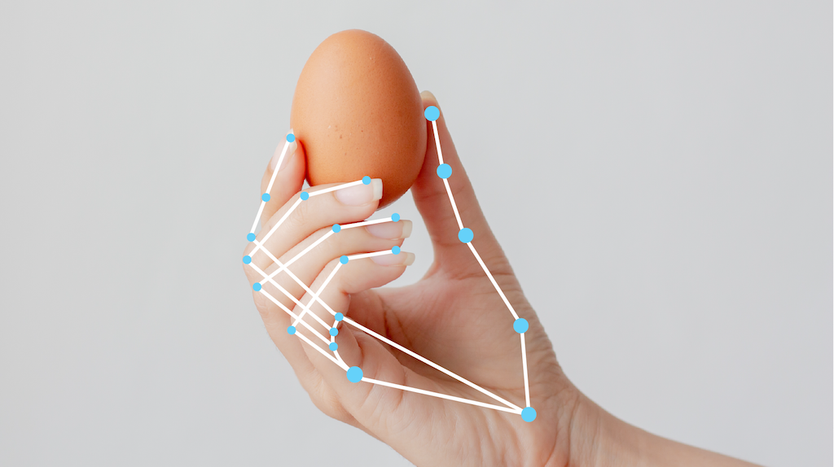

1.2 Problem Definition

Develop a real-time hand gesture recognition system to detect and count the number of extended fingers.

Map the recognized gestures to four answer options (1, 2, 3, and 4) in an MCQ quiz system.

Ensure hands-free interaction, with automatic answer selection every 8 seconds based on the displayed finger count.

Optimize performance to handle diverse environments, including varying lighting and hand orientations.

Evaluate the effectiveness of the system in terms of accuracy, response time, and user experience.

The primary objective of finger counting recognition is to accurately identify and count the number of fingers raised by a person. This process typically involves several key steps:

1. **Image Acquisition**: Capturing video frames or images using a camera.
2. **Preprocessing**: Enhancing the image quality through techniques such as normalization, noise reduction, and color space transformation.
3. **Hand Detection**: Identifying the region of interest (ROI) that contains the hand using algorithms like Haar cascades, Mediapipe, or deep learning-based methods.
4. **Finger Detection**: Analyzing the hand ROI to identify the individual fingers. This may involve contour detection or machine learning models trained to recognize finger positions.
5. **Counting Fingers**: Implementing logic to count the detected fingers accurately, considering different hand orientations and positions.

1.3 Challenges of project

**Environmental Factors**

* **Lighting Conditions**: Variations in lighting (e.g., low light, backlighting, or glare) can reduce the accuracy of hand detection. The system needs to adapt to different lighting environments to ensure reliable recognition.
* **Background Noise**: Complex or cluttered backgrounds may interfere with the system’s ability to detect hands accurately, leading to false positives or recognition errors.
* **Camera Quality and Positioning**: Differences in webcam resolution and placement can affect gesture recognition, requiring careful calibration to maintain consistency.

**Gesture Variability**

* **Hand Orientation and Positioning**: The system must account for different hand angles and orientations (e.g., tilted or partially visible hands). Detecting gestures accurately under these conditions is challenging.
* **Individual Differences**: Variations in hand size, finger length, and skin tone can influence the performance of the system, requiring robust algorithms to generalize well across users.
* **Occlusion**: Situations where fingers overlap or the hand is partially hidden from the camera can cause the system to miscount the number of extended fingers.

**Real-Time Performance**

* **Processing Speed**: Real-time detection and response require optimized algorithms to avoid lag or delays. Balancing speed and accuracy is critical to ensure smooth interaction.
* **Resource Limitations**: Running the system on lower-end devices, such as laptops with limited processing power, poses challenges for real-time performance. Efficient algorithms are necessary to maintain usability across different hardware configurations.

**Gesture Stability and Selection Timing**

* **Inconsistent Gestures**: Users may struggle to hold gestures consistently, leading to unintended changes in the recognized answer. The system must reliably differentiate between stable and transitional gestures.
* **Timing Issues**: Automatic answer selection every 8 seconds requires precise timing. If the system misinterprets a gesture at the moment of selection, it could lead to incorrect answers.

**Accuracy and Error Handling**

* **False Positives and Negatives**: The system may incorrectly detect gestures or fail to recognize valid gestures, affecting the user experience.
* **Error Feedback**: Providing meaningful feedback when the system misinterprets a gesture is essential for maintaining user trust and engagement. However, designing an effective feedback mechanism without complicating the interface is challenging.

**Usability and User Experience**

* **User Learning Curve**: Users unfamiliar with gesture-based systems may need time to adjust to the interface. Ensuring the system is intuitive and easy to use is essential.
* **Fatigue and Comfort**: Prolonged use of gesture-based systems may cause hand fatigue, reducing user comfort and engagement. The system must be designed with ergonomic considerations to minimize strain.

These challenges provide insight into the complexities involved in building a reliable and user-friendly gesture recognition system.

CHAPTER 2: Theoretical Background

This chapter discusses the key concepts, tools, and libraries that underpin the development of the hand gesture recognition system. The project leverages several computer vision frameworks, image processing tools, and programming techniques to enable real-time gesture recognition.

2.1 Computer Vision and Gesture Recognition:

Computer vision refers to the field of enabling machines to interpret and analyze visual data. Gesture recognition is a subdomain that focuses on recognizing movements or postures, such as hand gestures, as input for computers. The goal in this project is to identify the number of extended fingers and map these to predefined multiple-choice answers.

Gesture recognition involves several key stages:

* Hand detection: Identifying the presence of a hand in the camera feed.
* Feature extraction: Detecting landmarks such as finger tips and joints to understand the gesture.
* Gesture mapping: Counting fingers and mapping the result to a quiz answer.

2.2 Tools and Libraries

2.2.1 OpenCV (Open Source Computer Vision Library)



OpenCV is a powerful open-source library used for computer vision tasks. It provides various tools for image and video processing, making it ideal for capturing and analyzing webcam feeds.

Functions used:

* cv2.VideoCapture() to access the webcam.
* cv2.imshow() to display the video feed with visual cues.
* Image processing techniques such as thresholding and contour detection.

2.2.2 MediaPipe

MediaPipe is a cross-platform framework developed by Google that offers high-performance pipelines for real-time perception. For this project, the MediaPipe Hands module is used to detect hand landmarks. The library identifies 21 key points on the hand, including finger tips, joints, and the wrist.

Applications in this project:

* Detecting hand landmarks and calculating finger counts.
* Tracking hand orientation to ensure accuracy even when the hand moves.

MediaPipe Solutions are available across multiple platforms. Each solution includes one or more models, and you can customize models for some solutions as well.

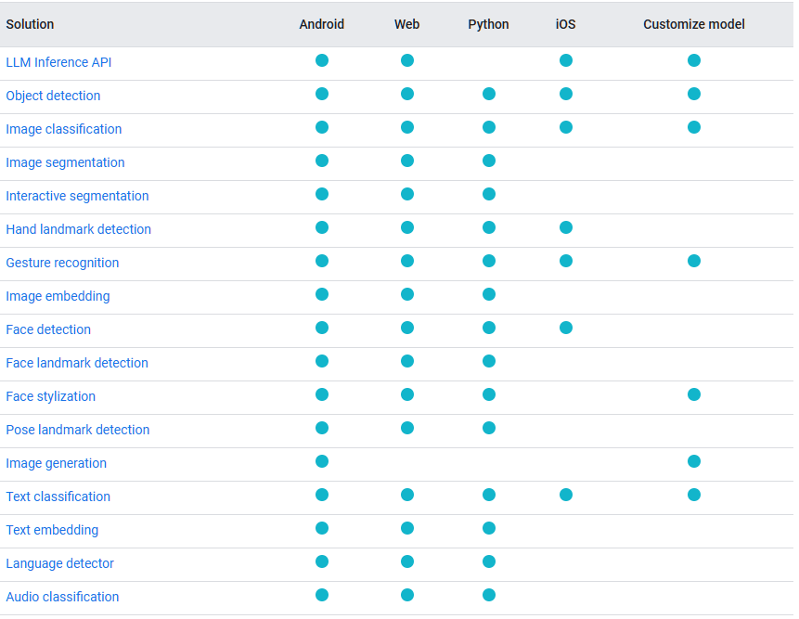

**Mediapipe in hand detection**



The MediaPipe Hand Landmarker task enables you to identify hand landmarks within an image. This functionality allows you to pinpoint key points on the hands and apply visual effects accordingly. The task works with image data, utilizing a machine learning (ML) model for either static images or continuous streams, and it produces outputs that include hand landmarks in both image coordinates and world coordinates, as well as the identification of handedness (left or right hand) for multiple detected hands.

**Palm Detection Model**

a single-shot detector model optimized for mobile real-time uses in a manner similar to the face detection model in MediaPipe Face Mesh. Detecting hands is a decidedly complex task: our lite model and full model have to work across a variety of hand sizes with a large scale span (~20x) relative to the image frame and be able to detect occluded and self-occluded hands. Whereas faces have high contrast patterns, e.g., in the eye and mouth region, the lack of such features in hands makes it comparatively difficult to detect them reliably from their visual features alone. Instead, providing additional context, like arm, body, or person features, aids accurate hand localization. 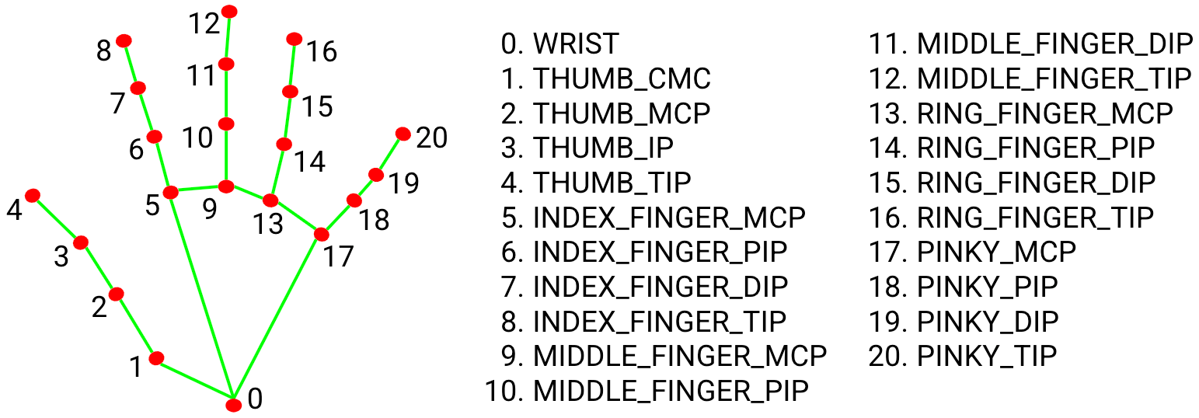

**Hand Landmark Model**

Following palm detection across the image, landmark model precisely localizes 21 3D hand-knuckle coordinates within the identified hand regions through regression, which involves direct coordinate prediction. The model learns a consistent internal representation of hand poses and remains robust even with partially visible hands and self-occlusions.

2.2.3 NumPy (Numerical Python)

NumPy is a library for handling large, multi-dimensional arrays and matrices, with a wide collection of mathematical functions to operate on these data structures.

Role in this project:

* Storing and processing the coordinate data of hand landmarks.
* Performing vector operations for computing distances between points (e.g., to check if fingers are extended).

CHAPTER 3: Configuration/Parameters

3.1 Class Object Structure and Code Modularity

**Using a Hand Class**

To keep the code organized, the project employs a class-based structure for hand gesture recognition. A HandDetector class (imported as htm) encapsulates methods for detecting hand landmarks, counting fingers, and displaying the results on the video feed.

This modular approach provides several benefits:

* Code reusability: Functions can be reused across different parts of the project.
* Simplified code management: Logic related to hand detection and counting is isolated in the class.
* Encapsulation: Data processing and display logic are handled independently within the class.

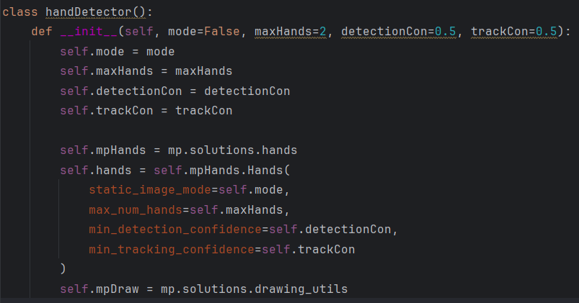

* Parameters of the Constructor:
* mode: If set to True, the model processes static images rather than video frames.
* maxHands: Maximum number of hands to detect.
* detectionCon: Minimum confidence threshold for detecting hands.
* trackCon: Minimum confidence threshold for tracking the hands.

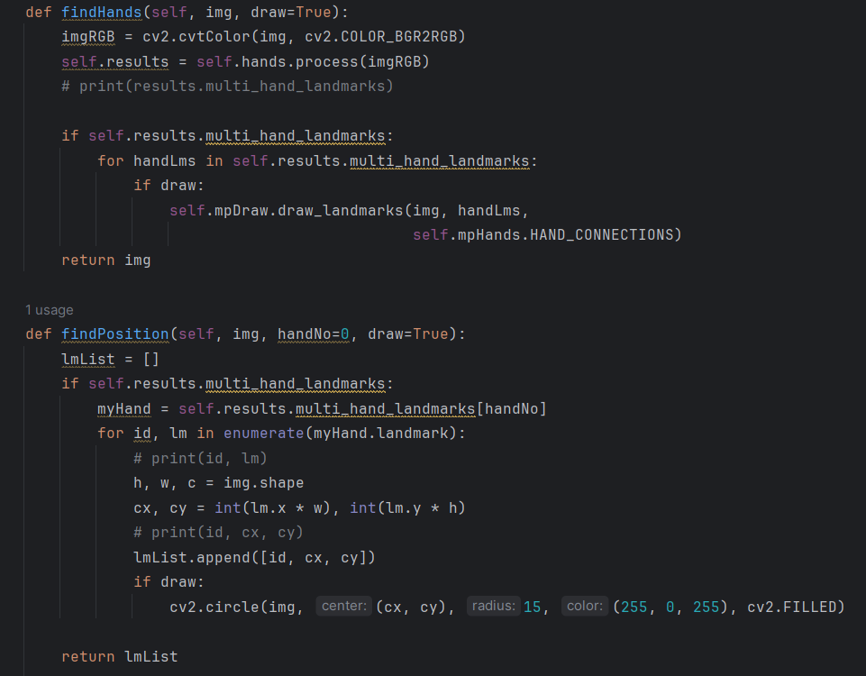

* findHands() converts the input image from BGR to RGB (required by MediaPipe).
* self.hands.process() processes the frame to detect hands and returns the results.
* If hand landmarks are found, they are drawn on the image using draw_landmarks().
* findPosition() extracts the coordinates of each detected landmark.
* It scales the landmark positions from relative values (0-1) to pixel coordinates based on the image dimensions.
* If draw=True, the method draws circles on the detected landmark points for visualization.

3.2 Hand Detection Setup

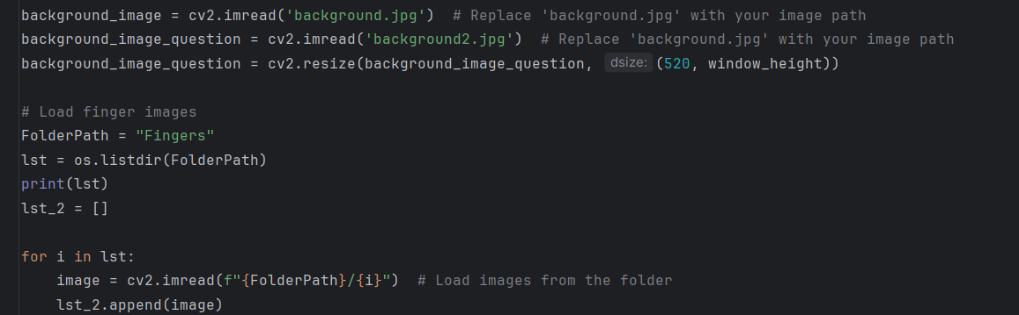

* cv2.imread(): Load background images.
* Resizing: The question background image is resized to fit the window.
* os.listdir(): Lists all images from the "Fingers" folder and stores them in lst_2 for later display.

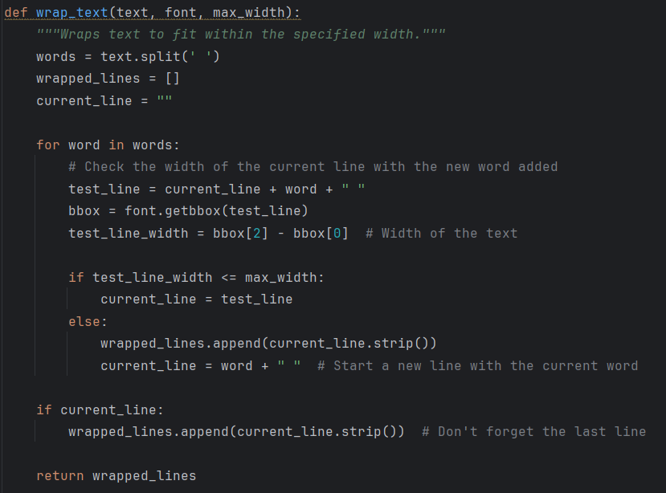

Purpose: Ensures that text fits within a given width by splitting it into multiple lines.

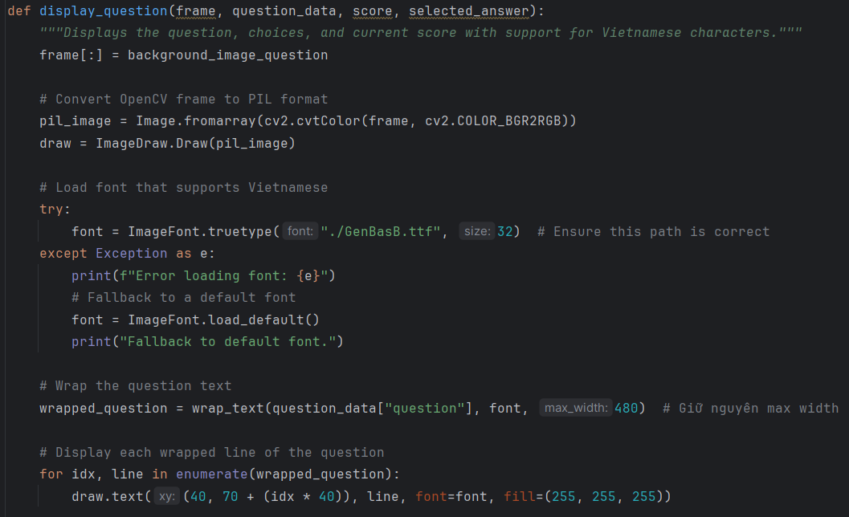

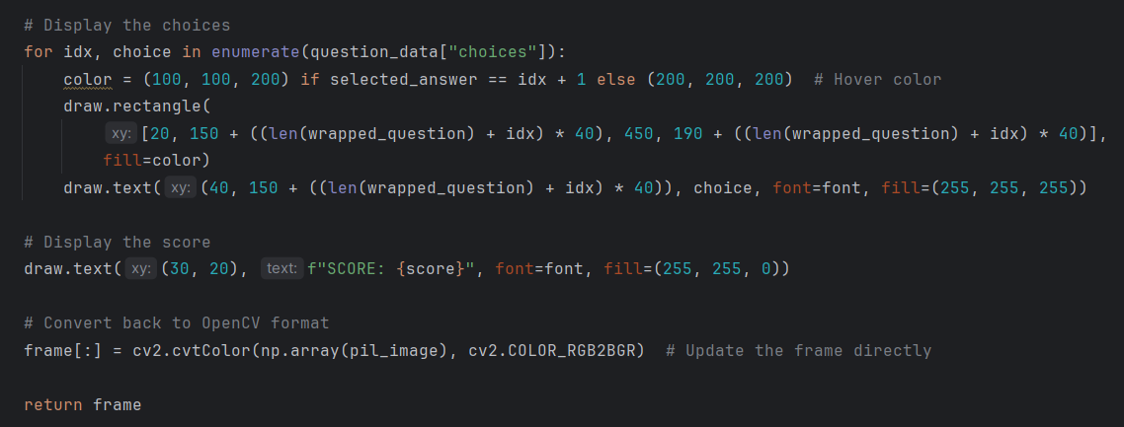

1. Draws the quiz question and answer choices on a background image.
2. Highlights the selected answer based on user input.
3. Supports Vietnamese characters by converting the frame between OpenCV and PIL formats.
4. Displays the current score at the top of the frame.

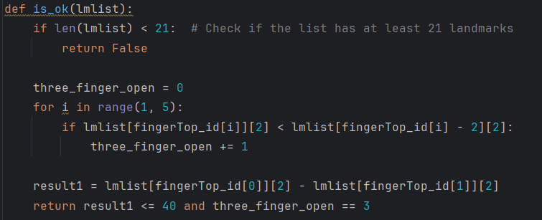

Checks if the OK gesture is shown: It uses landmark positions to determine the state of the hand.

1. Verify if the detected hand is performing an OK gesture.
2. It checks whether 3 specific fingers are extended, while the thumb and index finger form a close gap.

**FingerTop_id**: A list containing the landmark IDs for the tips of each finger (e.g., [4, 8, 12, 16, 20]).

* Index: 1-4 correspond to the index, middle, ring, and pinky fingers.

**Finger Extension Logic:**

* For each finger (excluding the thumb), it compares the y-coordinate of the fingertip (lmlist[fingerTop_id[i]][2]) with the y-coordinate of the middle joint (lmlist[fingerTop_id[i] - 2][2]).
* If the fingertip is above the middle joint, the finger is considered open (y-values decrease as you move up in the image).

**Three_finger_open**: The sum of all open fingers. The result will be 3 if exactly 3 fingers (index, middle, and ring fingers) are extended.

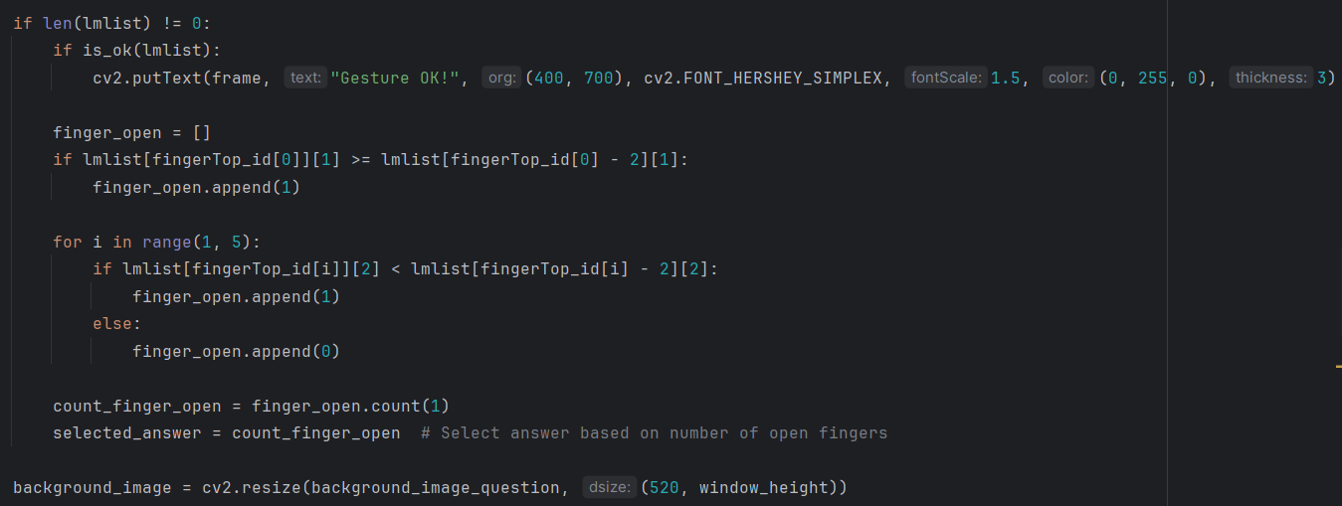

* lmlist: A list of detected hand landmarks.
* If hand landmarks are present, the is_ok() function is called to check if the 'OK' gesture is detected.
* If the OK gesture is detected, a message ("Gesture OK!") is displayed on the screen using OpenCV’s putText() function.
* finger_open List: Stores the state of each finger (1 for open, 0 for closed).
* Thumb Check: If the thumb is positioned horizontally, it is considered open.
* For the other four fingers, their y-coordinates are compared (tip < middle joint means open).
* selected_answer: The total count of open fingers corresponds to the selected answer for the quiz (1–4).

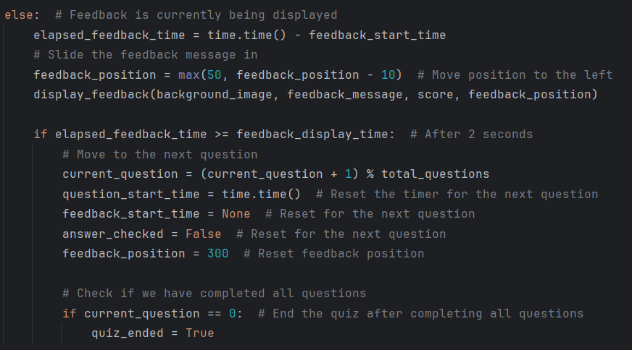

**Feedback Display:**

* Feedback message slides in by decreasing its horizontal position (feedback_position).
* After 2 seconds, the quiz moves to the next question.
* If all questions are completed, quiz_ended is set to True, ending the quiz.

3.3 Webcam Handling

The webcam stream is read frame-by-frame.

The loop ensures continuous processing until the user presses 'q' to quit.

3.4 Summary of the Code Logic:

1. Gesture-Based Start: The quiz starts when the OK gesture is detected.
2. Answer Selection with Fingers: The number of open fingers determines the selected answer (1–4).
3. Score Updates: Points are added or deducted based on the correctness of the selected answer.
4. Feedback and Transition: Feedback is shown after each question, and the quiz automatically moves to the next question after a brief delay.
5. Quiz End: When all questions are completed, the quiz ends.

CHAPTER 4: Experimental results

4.1 Gesture Recognition Results

Below are images showing the system's ability to accurately detect the number of fingers raised by the user. The correct gestures (0, 1, 2, 3, and 5 fingers) are detected on the first screen, mapped to the respective answer choices in the quiz system.

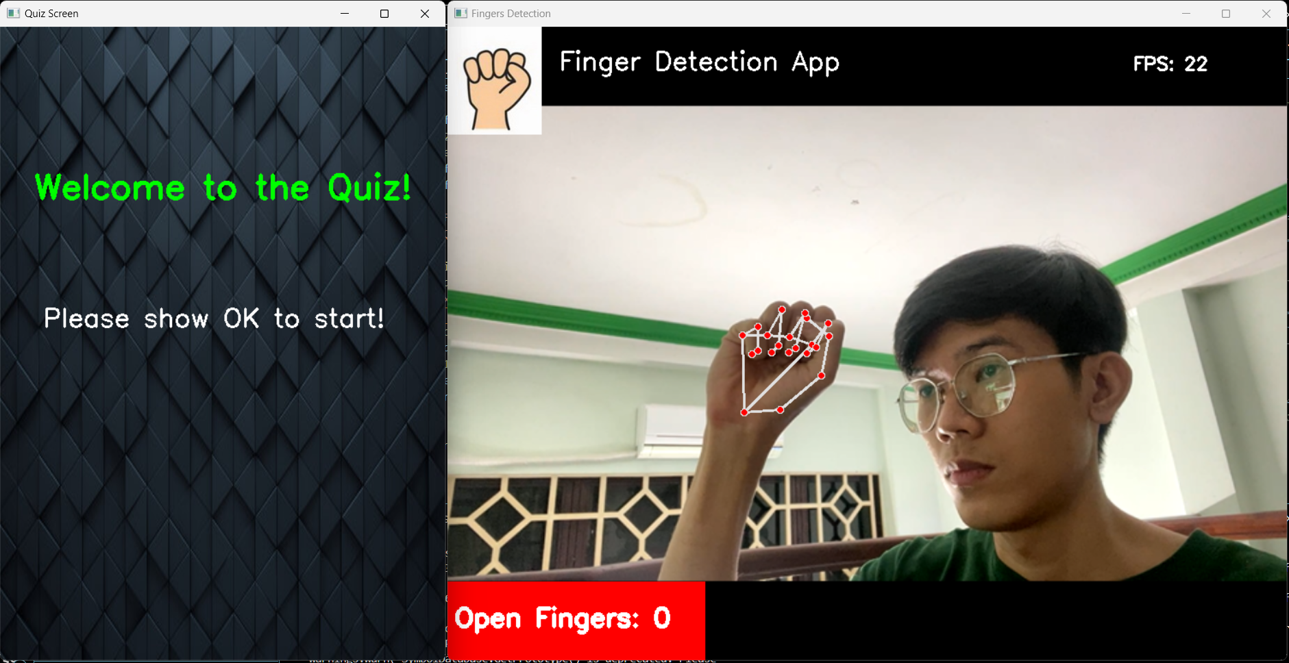

Figure 4: Zero Finger Detected

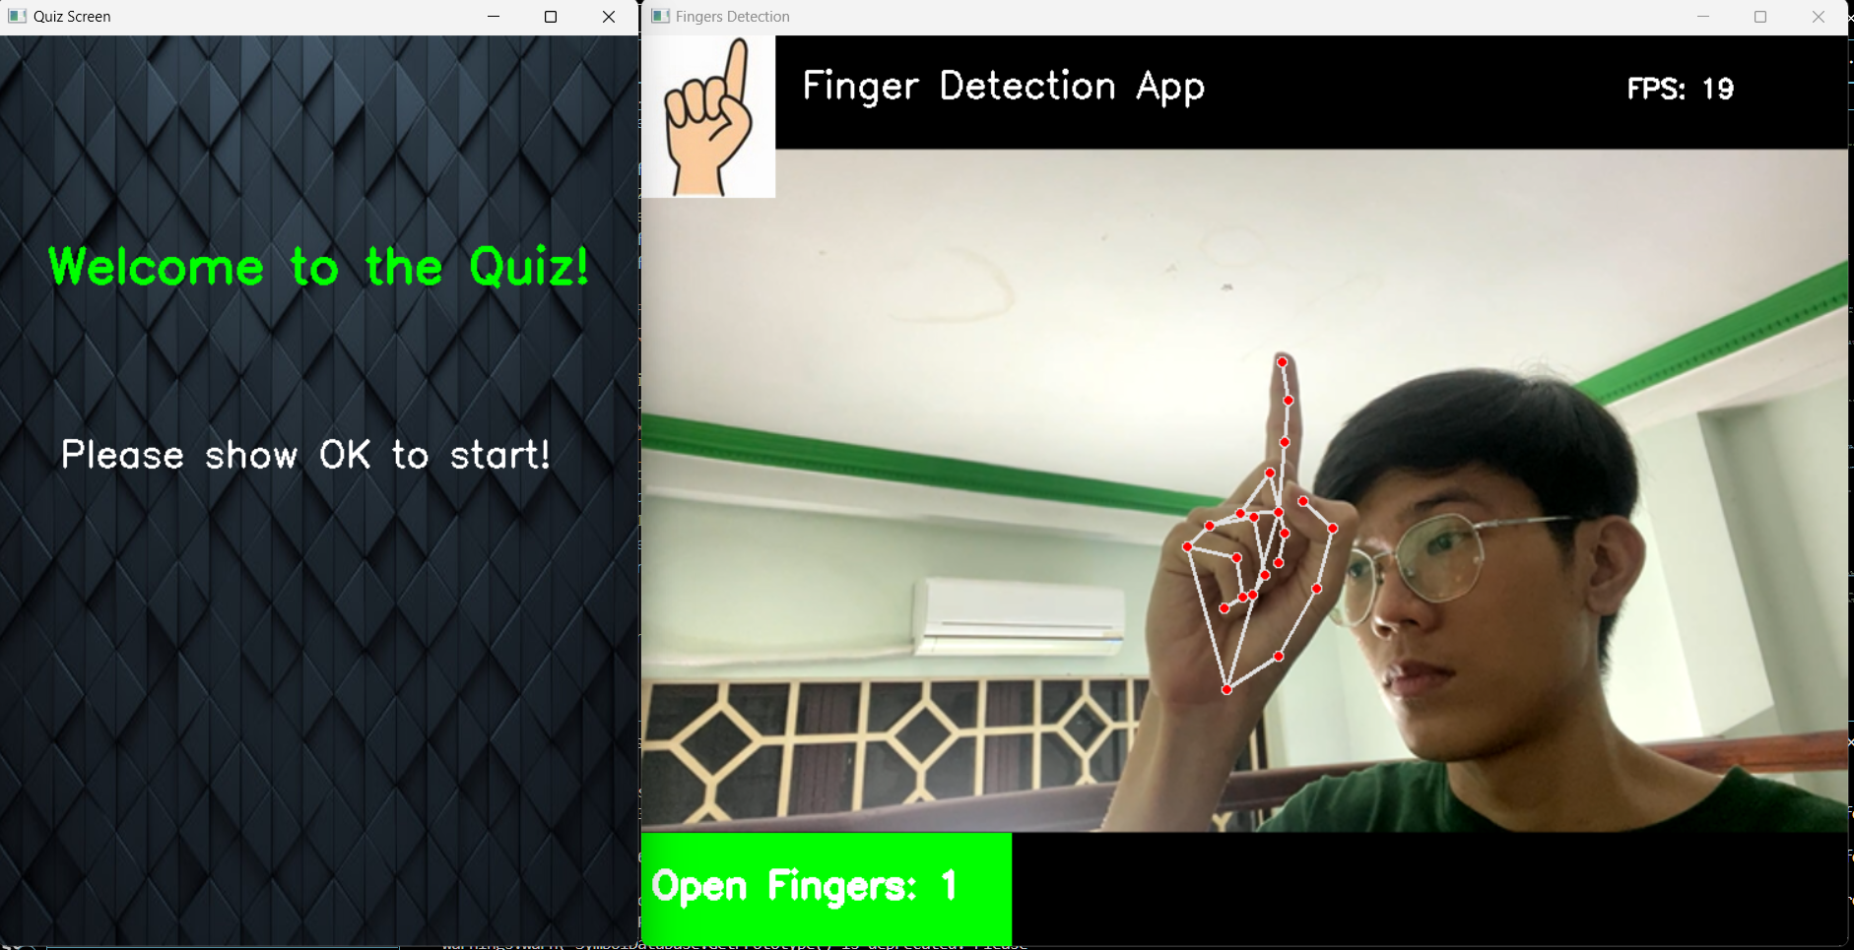

Figure 4.1: One Finger Detected

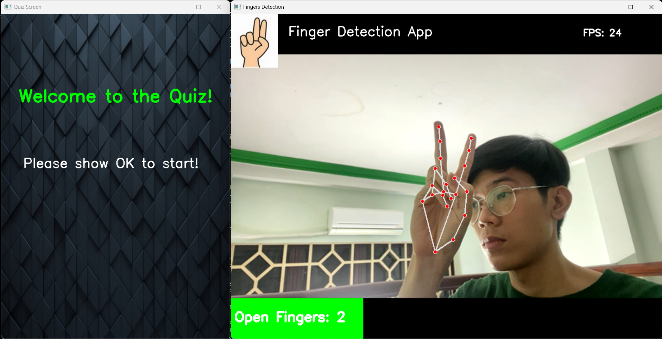

Figure 4.2: Two Fingers Detected

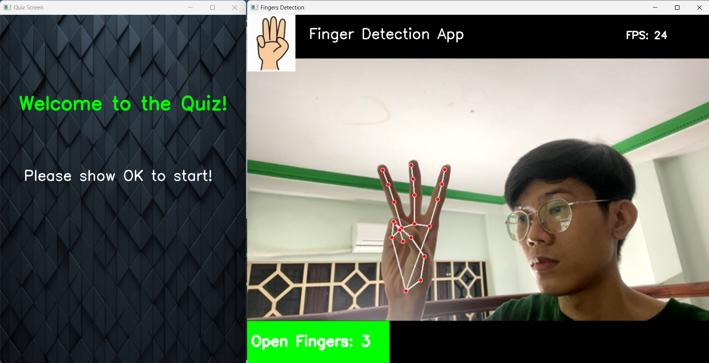

Figure 4.3: Three Fingers Detected (Answer 3 Selected)

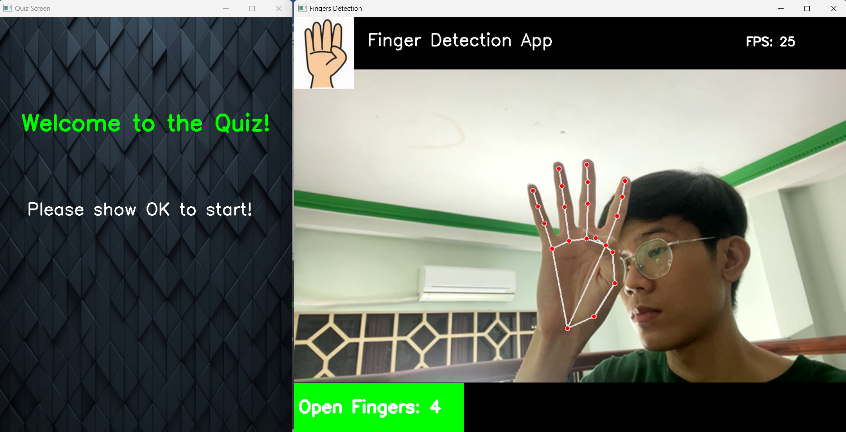

Figure 4.4: Four Fingers Detected

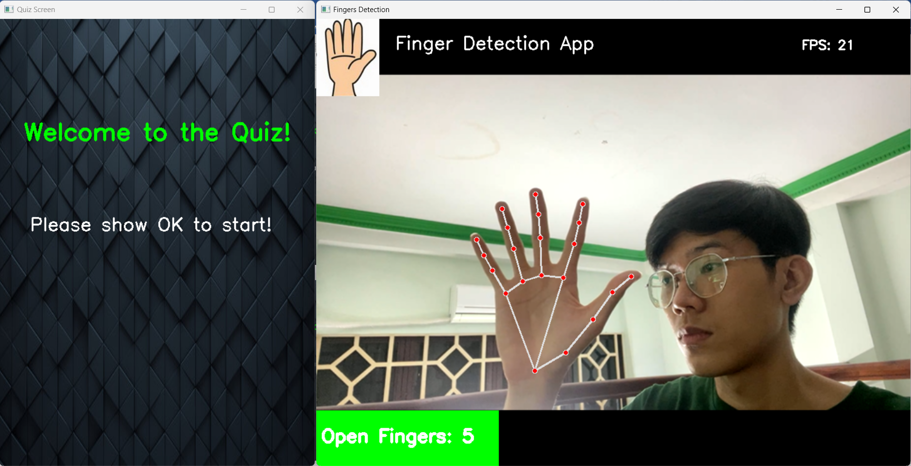

Figure 4.5: Five Fingers Detected

4.2 Starting the Quiz with "OK" Gesture

Each question in the quiz system is displayed for 8 seconds. During this time, the system detects the raised fingers to select an answer automatically. If the user provides no answer (i.e., no fingers shown), the system responds with a default feedback message indicating no answer was given.

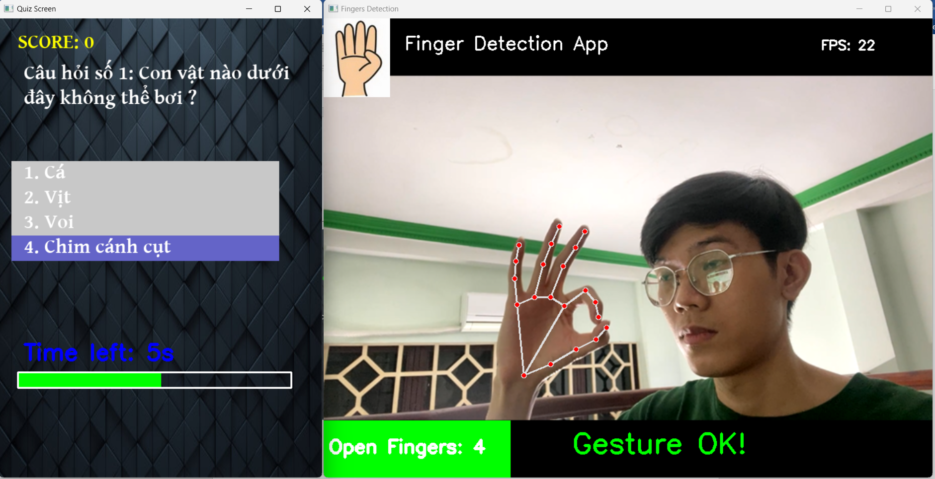

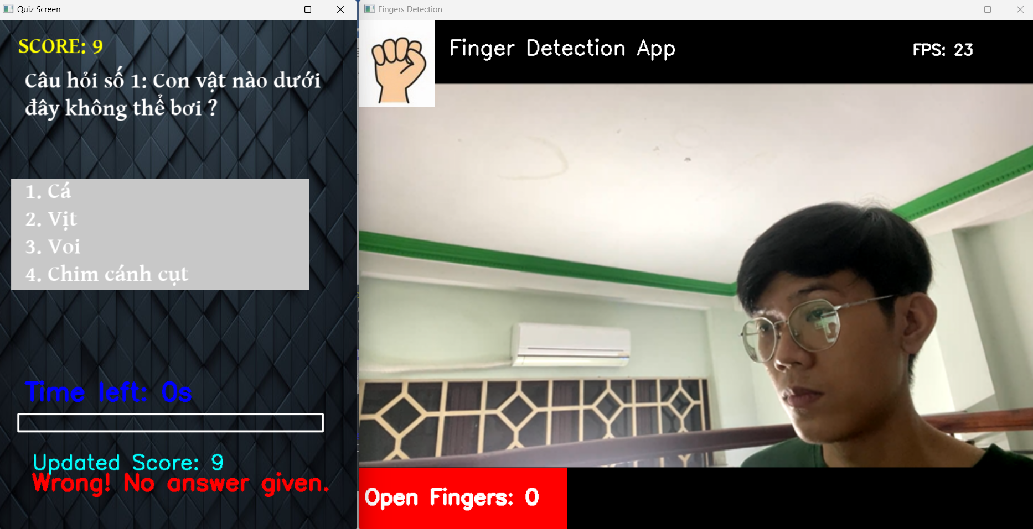

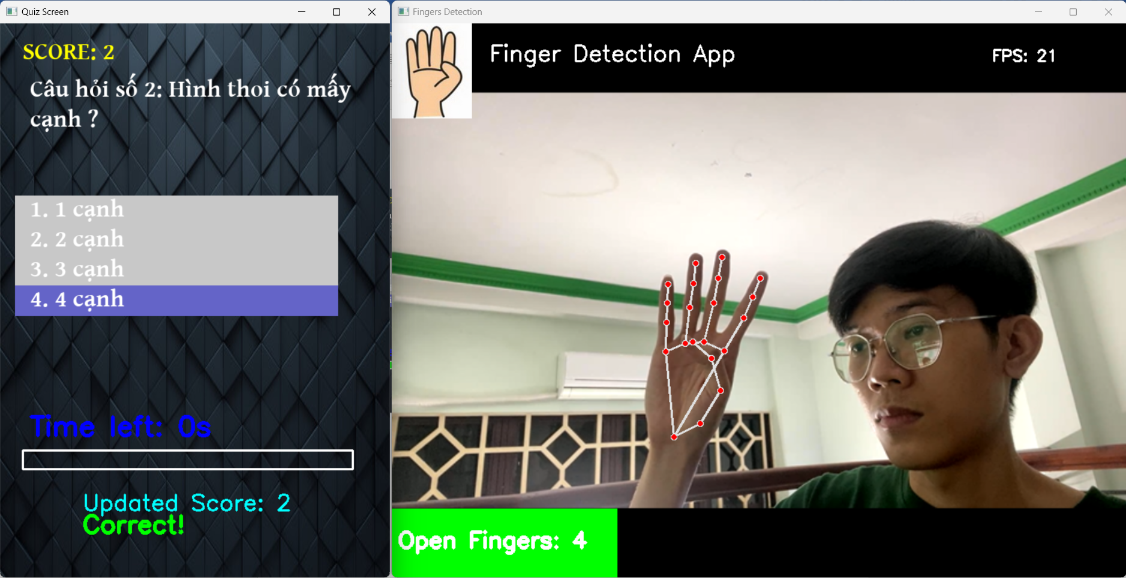

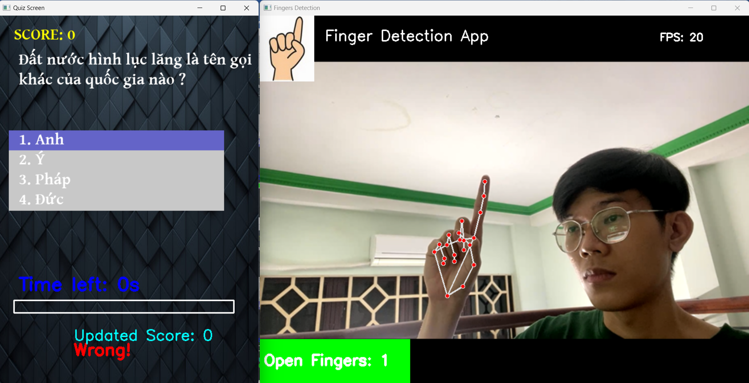

4.3 System Accuracy and Performance

The following observations were made during the experimental testing:

* + Accuracy:
* The system achieved high accuracy in recognizing individual gestures (1-4 fingers) under well-lit conditions.
* OK gesture detection also performed reliably, ensuring smooth quiz startup.
* Challenges:
* In low-light environments, the detection rate dropped slightly, leading to incorrect or missed recognition.
* Some gestures (like distinguishing between 2 and 3 fingers) required stable hand positioning for accurate detection.

4.4 Conclusion

This project showcases the potential of computer vision-based gesture recognition for interactive applications. The current implementation demonstrates the feasibility of using simple hand gestures to answer multiple-choice questions without the need for physical input devices. With the planned expansions—such as mobile integration, new gestures, and multi-user support—the system could become a more versatile tool for education, entertainment, and accessibility-focused applications.

These future developments will ensure the system evolves into a more powerful platform for gesture-based interaction, pushing the boundaries of what is possible with real-time computer vision and human-computer interaction.

REFERENCE

https://docs.opencv.org/4.x/index.html

https://ai.google.dev/edge/mediapipe/solutions/guide